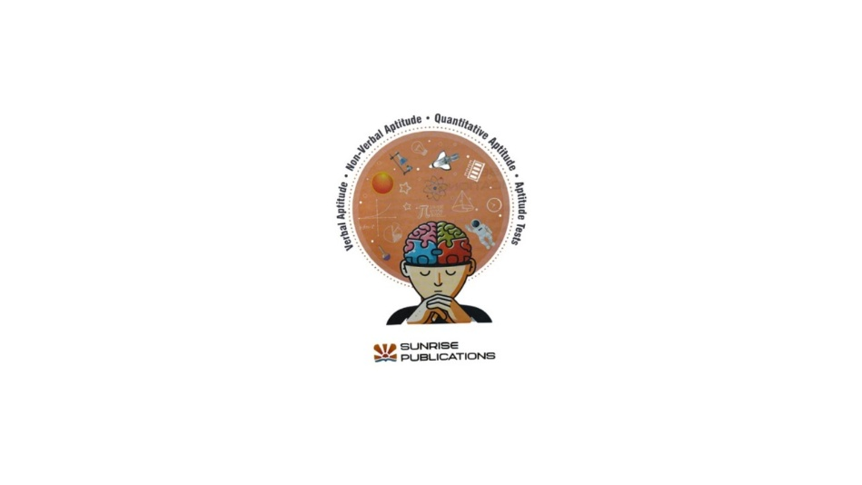
Learn
Aptitude skills
Analogy (Word-1)
PART A: VERBAL APTITUDE
Analogy (Words-1)
Analogy shows relationship between two similar things.
The relationship between the first and the second term is similar to that between the third and fourth term.
Example:
Land : Cow :: Pond : ?
(a) Fish
(b) Dog
(c) Bear
(d) Kitten
Answer: (a) Fish
Explanation:
- A cow lives on land.
- A fish lives in a pond.
So, Land : Cow is like Pond : Fish.

Tick (✔) the right choice.

1. Hockey : Stick :: Cricket : ?
(a) Team
(b) Bat
(c) Ground
(d) Ball
Correct Answer: (b) Bat
Why? (Steps/Logic)
- Hockey is played with a stick.
- Cricket is played with a bat.
So the relationship is game : main equipment.
Note:
Always try to see “What is this used for?” or “Which thing is needed to play this game?”

2. Book : Author :: Painting : ?
(a) Artist
(b) Brush
(c) Colour
(d) Soldier
Correct Answer: (a) Artist
Why? (Steps/Logic)
- A book is created/written by an author.
- A painting is created/made by an artist.
So the relationship is creation : creator.
Note:
If the first word is something made (book), the second word is usually the person who makes it (author).

3. Car : Road :: Boat : ?
(a) Air
(b) Dock
(c) Water
(d) Port
Correct Answer: (c) Water
Why? (Steps/Logic)
- A car moves on the road.
- A boat moves on water.
So the relationship is vehicle : where it moves.
Note:
Think: “Where does this usually travel?”

4. Pen : Writing :: Keyboard : ?
(a) Playing
(b) Typing
(c) Reading
(d) Singing
Correct Answer: (b) Typing
Why? (Steps/Logic)
- A pen is used for writing.
- A keyboard is used for typing.
So the relationship is tool : its main action/use.
Note:
Check which action is most closely connected to that object in daily life.

5. Doctor : Hospital :: Chef : ?
(a) Kitchen
(b) Post office
(c) School
(d) Ground
Correct Answer: (a) Kitchen
Why? (Steps/Logic)
- A doctor usually works in a hospital.
- A chef usually works in a kitchen.
So the relationship is person : workplace.
Note:
When you see a profession (doctor, chef, teacher), ask: “Where does this person normally work?”

6. Cat : Meow :: Dog : ?
(a) Squeak
(b) Purr
(c) Hiss
(d) Bark
Correct Answer: (d) Bark
Why? (Steps/Logic)
- A cat makes the sound “meow”.
- A dog makes the sound “bark”.
So the relationship is animal : its sound.
Note:
For such questions, remember common animal sounds:
- Cat → meow
- Dog → bark
- Cow → moo
- Lion → roar

General Tips / Suggestions for Analogy Questions
- Identify the relationship first
  - Is it tool–use, person–place, animal–sound, object–creator, vehicle–place etc.?
- Say it in a sentence
  - Example: “A doctor works in a hospital.”
  - Then match the same sentence pattern: “A chef works in a kitchen.”
- Eliminate wrong options
  - Remove options that have no logical relation.
  - If two seem close, choose the one that fits the pattern exactly.
- Practice with your own examples
  - Make your own pairs:
    - Teacher : School :: Doctor : ? (Hospital)
    - Bird : Sky :: Fish : ? (Water)
Analogy (Word-2)
Analogy (Words-2)
Analogy shows relationship between two similar things.
The relationship between the first and second pair should be the same as the relationship between the third and fourth.

Example:
Crow : Bird :: ?
(a) Fish : Water
(b) Cow : Mammal
(c) Milk : Sugar
(d) Egg : Hen
Answer: (b) Cow : Mammal
Explanation:
- A crow is a type of bird.
- A cow is a type of mammal.
So the pattern is “thing : the group/type it belongs to”.

Tick (✔) the right choice.

1. Fish : Swimming :: ?
(a) Cat : Sleeping
(b) Dog : Barking
(c) Woodcutter : Eating
(d) Bird : Flying
Correct Answer: (d) Bird : Flying
Why? (Steps/Logic)
- Fish is an animal and swimming is its usual action.
- Bird is an animal and flying is its usual action.
So the pattern is animal : its common action.
Note:
Ignore options that don’t show a natural or special action (like “Eating” – all do that).

2. Skating : Rink :: ?
(a) Cricket : Bat
(b) Badminton : Court
(c) Football : Goal
(d) Hockey : Stick
Correct Answer: (b) Badminton : Court
Why? (Steps/Logic)
- Skating is done on a rink (place).
- Badminton is played on a court (place).
So the relationship is game/sport : place where it is played.
Note:
Check if the second word is a place, not an object (bat, stick, goal are not places).

3. Virat Kohli : Cricket :: ?
(a) P.T. Usha : Football
(b) Rohit Sharma : Hockey
(c) Saina Nehwal : Badminton
(d) Dhyanchand : Tennis
Correct Answer: (c) Saina Nehwal : Badminton
Why? (Steps/Logic)
- Virat Kohli is a famous player of cricket.
- Saina Nehwal is a famous player of badminton.
So the pattern is sportsperson : their correct sport.
Note:
Use your general knowledge of famous Indian players.

4. Student : Teacher :: ?
(a) Patient : Doctor
(b) Student : Class
(c) Leader : Cap
(d) Nurse : Medicine
Correct Answer: (a) Patient : Doctor
Why? (Steps/Logic)
- A student is guided/taught by a teacher.
- A patient is treated/cared for by a doctor.
So the relationship is person who receives help : person who gives help/service.
Note:
Look for pairs where the second person has a role of helping or guiding the first.

5. Eyes : See :: ?
(a) Eyes : Blink
(b) Water : Fish
(c) Feel : Pride
(d) Mind : Think
Correct Answer: (d) Mind : Think
Why? (Steps/Logic)
- Eyes are used to see.
- Mind is used to think.
So the pattern is body part/organ : main function.
Note:
Option (a) “Eyes : Blink” is an action but not the main purpose. The stronger relation is Eyes → see, Mind → think.

6. Pen : Ink :: ?
(a) Pen : Paper
(b) Pencil : Graphite
(c) Eraser : Sharpener
(d) Pencil : Eraser
Correct Answer: (b) Pencil : Graphite
Why? (Steps/Logic)
- A pen contains ink inside it.
- A pencil contains graphite (the black lead) inside it.
So the pattern is writing tool : material inside used for writing.
Note:
Pen–paper and pencil–eraser are related, but not “inside content” relations.

7. Alphabet : Letters :: ?
(a) Dusk : Days
(b) Calendar : Months
(c) Months : Season
(d) Calendar : Hours
Correct Answer: (b) Calendar : Months
Why? (Steps/Logic)
- An alphabet is made up of letters.
- A calendar is made up of months.
So the pattern is whole : parts that make it up.
Note:
Ask: “What is this made of?”
- Alphabet → letters
- Calendar → months

General Suggestions for Students
- First, find the relation in the example pair
  - Is it part–whole, tool–use, person–profession, place–activity, animal–action?
- Make a simple sentence
  - “A fish does swimming.”
  - “A bird does flying.”
- Eliminate clearly wrong options
  - If the pattern is “game : place”, remove all pairs that are “game : object”.
- Use your common sense and GK
  - For sports personalities, professions, animal actions, body parts etc.

Analogy (Letters-1)
Tick (✔) the right choice.
Analogy (Letters-1)
In these questions, the relationship between the first pair of letters must be the same as the relationship between the second pair.

1. G : I :: J : ?
(a) K
(b) L
(c) M
(d) N
Correct Answer: (b) L
Explanation (Steps):
- G → I
- G = 7th letter, I = 9th letter → +2
- J = 10th letter
- J + 2 = 12th letter = L
👉 Pattern: “Add 2 positions in the alphabet.”

2. L : O :: Q : ?
(a) P
(b) R
(c) S
(d) T
Correct Answer: (d) T
Explanation:
- L = 12, O = 15 → +3
- Q = 17
- 17 + 3 = 20 = T
👉 Pattern: “Add 3 positions.”

3. S : Q :: P : ?
(a) L
(b) N
(c) O
(d) Q
Correct Answer: (b) N
Explanation:
- S = 19, Q = 17 → –2
- P = 16
- 16 – 2 = 14 = N
👉 Pattern: “Subtract 2 positions.”

4. D : W :: E : ?
(a) V
(b) U
(c) T
(d) S
Correct Answer: (a) V
Explanation:
Here they are using mirror letters (A–Z, B–Y, C–X, D–W, etc.).
- D ↔ W (4 + 23 = 27)
- For E (5), the mirror is the letter that gives 27 with it: 5 + 22 = 27 → V
👉 Pattern: “Opposite/mirror letter in A–Z.”

5. KL : NO :: PQ : ?
(a) RS
(b) QS
(c) ST
(d) QR
Correct Answer: (c) ST
Explanation:
- K = 11 → N = 14 (+3)
- L = 12 → O = 15 (+3)
So add 3 to each letter in PQ:
- P = 16 → 16 + 3 = 19 = S
- Q = 17 → 17 + 3 = 20 = T
So we get ST.
👉 Pattern: “Add 3 to both letters.”

6. LM : P :: QR : ?
(a) T
(b) W
(c) U
(d) V
Correct Answer: (c) U
Explanation:
For LM → P:
- L = 12, M = 13
- Result P = 16
- 12 + 4 = 16 and 13 + 3 = 16
So for QR:
- Q = 17 (+4 → 21 = U)
- R = 18 (+3 → 21 = U)
So answer is U.
👉 Pattern: “From first letter +4, or second letter +3 → same result.”

7. A : BD :: P : ?
(a) QR
(b) RS
(c) PQ
(d) QS
Correct Answer: (d) QS
Explanation:
- From A to BD:
  - B = A + 1
  - D = A + 3
For P:
- P + 1 = Q
- P + 3 = S
So we get QS.
👉 Pattern: “Form a pair with +1 and +3 from the first letter.”

8. GH : JK :: MN : ?
(a) EF
(b) QR
(c) OP
(d) PQ
Correct Answer: (d) PQ
Explanation:
- G = 7 → J = 10 (+3)
- H = 8 → K = 11 (+3)
For MN:
- M = 13 → +3 = 16 = P
- N = 14 → +3 = 17 = Q
So we get PQ.
👉 Pattern: “Each letter is shifted +3.”

9. ABC : F :: KLM : ?
(a) S
(b) R
(c) P
(d) Q
Correct Answer: (c) P
Explanation:
- In ABC, last letter = C (3rd letter).
- F is 3 letters after C (C→D→E→F).
So: “Take last letter, then +3.”
For KLM:
- Last letter = M (13th).
- 13 + 3 = 16 = P.
👉 Pattern: “Last letter + 3.”

10. G : HJK :: P : ?
(a) STQ
(b) QST
(c) QTS
(d) STU
Correct Answer: (b) QST
Explanation:
From G to HJK:
- H = G + 1
- J = G + 3
- K = G + 4
So for P:
- P + 1 = Q
- P + 3 = S
- P + 4 = T
So the group should be QST.
👉 Pattern: “Make a 3-letter group using +1, +3, +4 from the first letter.”

11. NOP : QR :: VWX : ?
(a) YZ
(b) ZY
(c) WX
(d) UV
Correct Answer: (a) YZ
Explanation:
From NOP to QR:
- NOP = N, O, P (14,15,16)
- They drop N and take O, P.
- O = 15 → +2 = Q (17)
- P = 16 → +2 = R (18)
Now for VWX (22,23,24):
- Drop V
- W = 23 → +2 = 25 = Y
- X = 24 → +2 = 26 = Z
So we get YZ.
👉 Pattern: “Drop first letter, then +2 to the other two.”

12. NO : RQP :: GH : ?
(a) LKJ
(b) KJI
(c) JIH
(d) IJK
Correct Answer: (b) KJI
Explanation:
From NO to RQP:
- N = 14
- R = 18 = 14 + 4
Then they go backwards: 18,17,16 → R, Q, P
So for GH:
- G = 7
- 7 + 4 = 11 = K
Then move backwards 11,10,9 → K, J, I
So we get KJI.
👉 Pattern:
- Take first letter.
- Add 4 for the first letter of the new group.
- Then write two previous letters in reverse order.

General Notes / Suggestions for Letter Analogies
- Write letter positions
  - A=1, B=2, … Z=26 helps a lot.
- Check for + / – patterns
  - See if letters are shifting by the same number.
- Look at whole pair, not single letter
  - Sometimes both letters move, sometimes one is dropped or added.
- Common patterns in such questions
  - Fixed shift (+2, +3, –2, etc.)
  - Mirror letters (A–Z, B–Y, C–X…)
  - Use of last letter of the group
  - Forming new groups from one letter (+1, +3, etc.)

“Rest of the chapters will be added soon.”

